

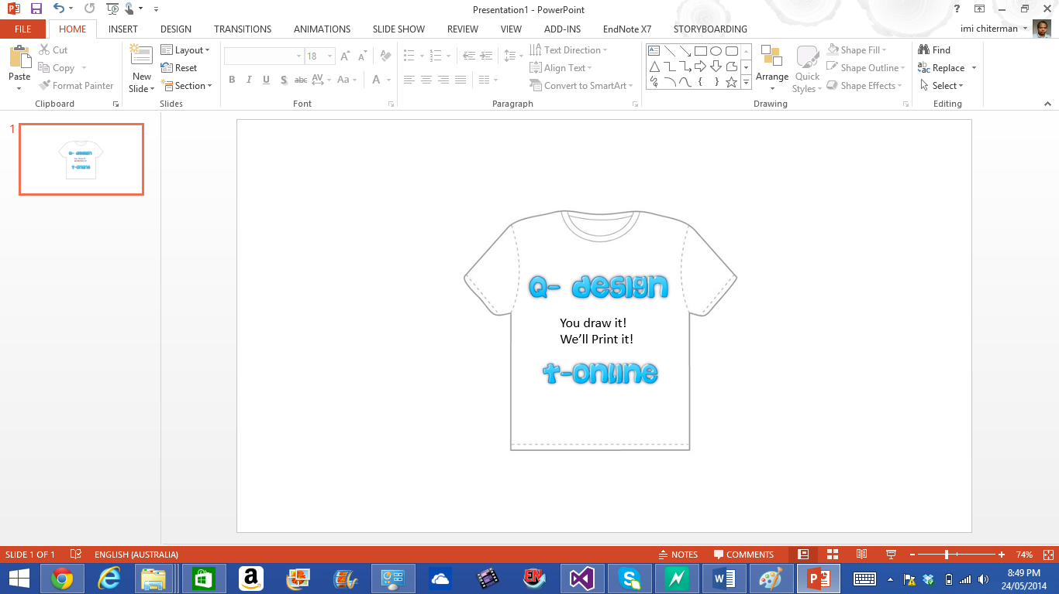

Q-Design T-shirt online web application

User manual guide

Contents

Application overview: 3

System Requirement: 3

Section 1: Accessing the system: 3

Section 2: Provided tolls and functionalities 4

Drawing and Object manipulation 6

Section 3: Free hand drawing 6

Section 4: Adding Text to canvas area 6

Section 5: Selecting, resizing and rotating objects on canvas 6

Section 6: Selecting and deleting objects on canvas 6

# Application overview:

The online system is a simple design tool for client to design their own unique T-shirt textile. A user can quickly upload standard images from their computer directly into the web application, perform image transformation, merge and mix text, free hand drawing and create collages of photos using this application. The application features a rich set of tools, providing end users with the ability to pick form various pen or market styles including pen size and colours.

All elements on the drawing canvas becomes individual objects allows the end user to select, resize, rotate and even delete elements from the canvas.

Once a design is completed a preview of on the final image can be generated on the t-shirt, giving the customer an appreciation of what the printed output will be.

This end use manual is designed to get user up and running within five (5) minutes to design their very own t-shirt, online.

# System Requirement:

A live broadband internet connection

**The system is a web application, requiring computer with any operating system to have installed:**

Web browser supporting HTML5 standards – Popular browsers such as Google Chrome, Internet Explorer and Firefox are known to support HTML 5 standards, once they are kept updated to the latest version releases.

**Optional:**

Touch screen devices and digitizing pen.

The system is designed to respond to touch interfaces and digitizing pens, these tools can aid in productivity and accuracy of drawing over the use of mouse movements.

# Section 1: Accessing the system:

To access your copy of the system, visit the following Url:

Once your computer meet the requirements the system should appear as seen in figure 1.0.

Figure : The interface of Q-Design t-Online

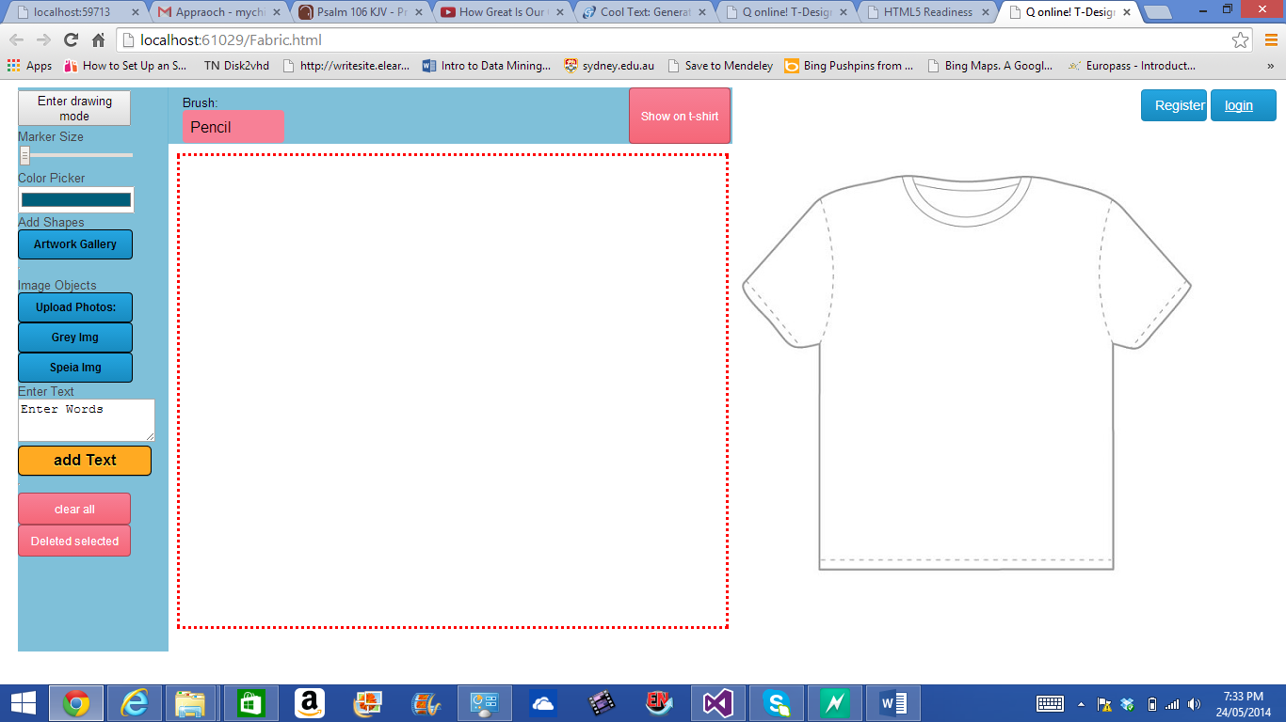

The left side of the screen shows the drawing tools and controls available for end users, which the right side show a t-shirt template where the design can be previewed during the drawing process. User are provided with login and registration pages located at the right top part of the screen.

## Section 2: Provided tolls and functionalities

Figure 2.0 provides the description of the currently available tools that can be used with the system.

Table : The list of tools and functions

| Tools | Button Name | Function |
| --- | --- | --- |
| Mode tool | Enter drawing mode | Allows the user to turn on or turn off drawing on the canvas when clicked. |
| Pen tip tool | Marker size | Allows the user to change the size of the current drawing pen. |
| Colour tool | Colour picker | Allows the user to change the colour of the drawing pen. |
| Gallery Tool | Gallery of images and shapes | A galley of basic shapes and iconic images that can be used to enhance a collage |
| Upload Tool | Upload Photo: | This tools allow end user to upload a photo from their computer onto the drawing canvas. |
| Grey tool | Grey img | The grey image button allow user to convert a selected image to grey version. |
| Speia tool | Speia img | The Speia image button allow user to convert a selected image to Speia version |
| Text tool | Enter words, add Text | Allows the user to type short text and add the same to canvas area. |
| Clear canvas tool | Clear all | Allow the user to reset the canvas to a blank drawing area. |
| Delete selected tool | Delete Selected | Allows the user to delete a selected object off the canvas. |
| Brush tool | Brush | Provides a list of brushes and patterns that can be used to draw. Default brush is the regular pen (pencil) tool tip. |
| Show tool | Show on t-shirt | Allow a preview of the current canvas objects to be projected onto the t-shirt (mini-map) area. |

The various tool provided with the system can be used in combination of each other, allow the user to manipulate various objects on the canvas to meet their requirements.

The canvas is a drawing area market with red outlining borders. A user needs can perform activities based on the selected tool within the canvas area.

Figure : Available tools with the drawing canvas.

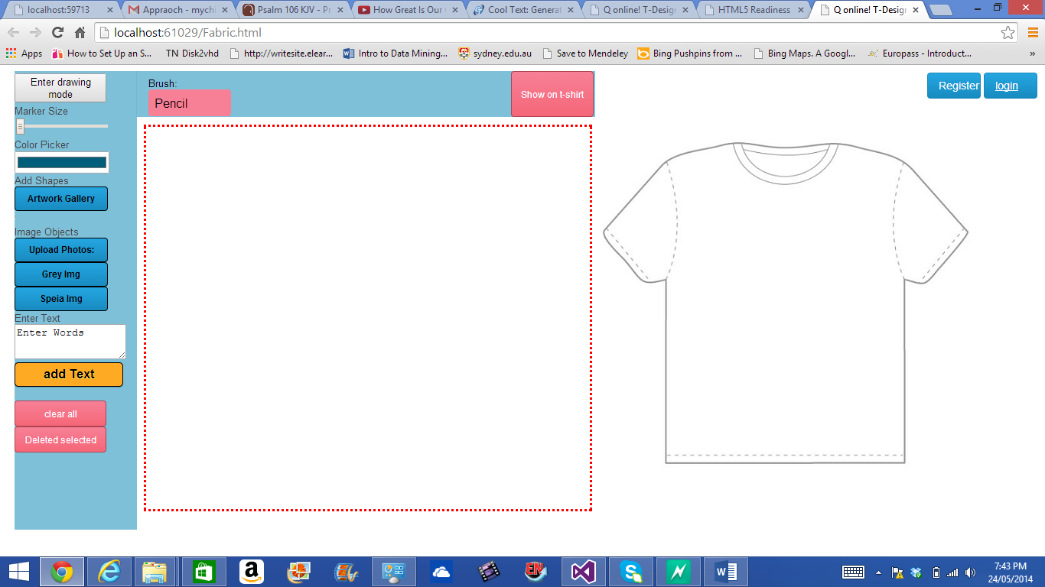

# Drawing and Object manipulation

## Section 3: Free hand drawing

The free hand drawing application does what it say, it allow users to drawing lines and create artwork using their mouse movement (or optional drawing tools).

See video on using the drawing canvas, with colour and tool tips. (Click here to visit the link)

## Section 4: Adding Text to canvas area

The canvas can accommodate text by using the Text tool bar.

## Section 5: Selecting, resizing and rotating objects on canvas

Selecting an object allows the user to perform, rotation and resizing of the object.

## Section 6: Selecting and deleting objects on canvas

Objects, including the drawn stroke of the pen can be selected and deleted from the canvas.